



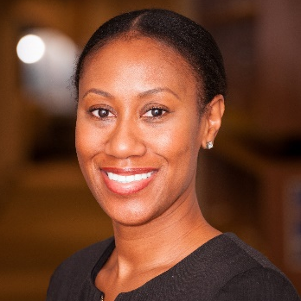

Driver’s License
- Code 8

Languages
- English/isiXhosa/Afrikaans

Education

Master’s Degree
College, University
20XX

Bachelor’s Degree
College, University
20XX

Certification (Membership)
Organization
20XX

Skills

- Contract Administration
- JBCC & FIDIC
- Building Works
- Microsoft Office
- Spreadsheets
- CCS Candy
- WinQS

References
Reference Name
Company Name
Phone Number

Reference Name
Company Name
Phone Number

+27 83 006 5274
kristel@example.com
Cape Town, WC, RSA
www.LinkedIn.com/

Contact

KRISTEL KANGRO
Senior Quantity Surveyor

Professional Summary

“Keep it short — 3 to 4 lines max. Focus on who you are, what you do best, and what value you bring. For example:
‘Detail-oriented Quantity Surveyor with 6 years’ experience in commercial construction, skilled in cost control, tendering, and project coordination.’”

Work experience

Quantity Surveyor

Arbitrage Construction, Durban 20XX- Present
Describe your accomplishments and job responsibilities briefly. Concentrate on the skills and strengths you've identified as relevant to the job description.
- Describe your job role in 3-4 bullet points. Avoid using too many bullets.
- Employers want to know what you've achieved. If possible, quantify what you have accomplished.
- Use simple language and make it easily readable. Recruiters who are unfamiliar with your specific field may review your resume.
- Include key words from the job description in your resume.

Senior Quantity Surveyor

Arbitrage Construction, Pretoria 20XX- 20XX
Describe your accomplishments and job responsibilities briefly. Concentrate on the skills and strengths you've identified as relevant to the job description.
- Be as precise as possible. Don’t write long paragraphs.
- Highlight your accomplishments but don't exaggerate; they will ask questions from your resume during the interview.
- If you are applying for a position in a new area, emphasize the skills you have established that will be useful in this position.

Senior Quantity Surveyor

Arbitrage Construction, Cape Town 20XX- 20XX
Describe your accomplishments and job responsibilities briefly. Concentrate on the skills and strengths you've identified as relevant to the job description.
- Describe your job role in 3-4 bullet points. Avoid using too many bullets.
- Employers want to know what you've achieved. If possible, quantify what you have accomplished.
- Use simple language and make it easily readable. Recruiters who are unfamiliar with your specific field may review your resume.

